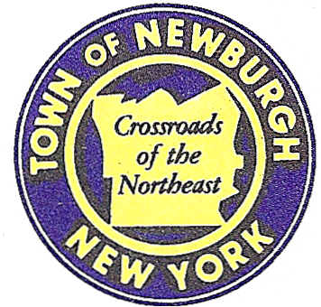

TOWN OF NEWBURGH
_______Crossroads of the Northeast __________________________
OLD TOWN HALL
308 GARDNERTOWN ROAD NEWBURGH, NEW YORK 12550

PLANNING BOARD
JOHN P. EWASUTYN, CHAIRMAN
TELEPHONE 845-564-7804
FAX 845-564-7802
E-MAIL: planningboard@townofnewburgh.org

PLANNING BOARD AGENDA

February 21, 2019

*PLEASE NOTE: The Planning Board Meeting will start at 7:00 P.M. and all Applicants/Representatives
are to be present at that time. The Meeting will be held in the Meeting Room of Town Hall,
located at 1496 Route 300, Newburgh NY.*

- A Plus Auto & Truck, LLC (18-17) SITE PLAN
12 Little Lane Road
Section 53, Block 4, Lot 4.21
Zone: B
Rep: Engineering and Surveying Properties, PC
71 Clinton St.
Montgomery, NY 12549

- Ngo (19-03) INITIAL APPEARANCE
Northeast corner of NY Route 300/Mt. View Ave. TWO FAMILY SITE PLAN/ARB
Section 14, Block 1, Lot 20
Zone: AR
Rep: Valdina Consulting Engineers
4 Pleasant View Ave.
Newburgh, NY 12550

- Newburgh Town Center (19-04) INITIAL APPEARANCE
1431 NY Route 300 SITE PLAN
Section 60, Block 3, Lot 29.11
Zone: IB
Rep: Maser Consulting
555 Hudson Valley Ave., Suite 101
New Windsor, NY 12553

*WORK SESSION*
Project Readiness Discussion scheduled for 5:30 p.m. in the Meeting Room of
Town Hall on Thursday, February 21st, 2019.*

PLANNING BOARD BUSINESS
WORK SESSION

*WORK SESSION*
Project Readiness Discussion scheduled for 5:30 p.m. in the Meeting Room of
Town Hall on Thursday, February 21st, 2019.*

